Trace the recursive Inorder traversal for tree below:

(Show the sequence of recursive calls and visits to nodes)

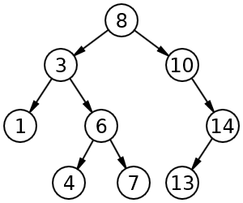

**Solution:**

printSub(root) – we will call this printSub(8)

printSub(8)

printSub(3)

printSub(1)

printSub(null)

visit 1

printSub(null)

visit 3

printSub(6)

printSub(4)

printSub(null)

visit 4

printSub(null)

visit 6

printSub(7)

printSub(null)

visit 7

printSub(null)

visit 8

printSub(10)

printSub(null)

visit 10

printSub(14)

printSub(13)

printSub(null)

visit 13

printSub(null)

visit 14

printSub(null)

Thus the inorder visit sequence is 1, 3, 4, 6, 7, 8, 10, 13, 14